Questions and/or Exercises to work out and turn in:

Grading Guidelines (See Appendix):

A right answer will get full credit when:

1. It is right (worth 25%)
2. It is right **AND** neatly presented making it easy and pleasant to read. (worth an **extra** 15%)
3. There is an **obvious and clear link** between 1) the information provided in the exercise and in class and 2) the final answer. A clear link is built by properly writing, justifying, and documenting an answer (worth an **extra** 60%).
4. Calculation mistakes will be minimally penalized (2 to 5% of full credit) while errors on units will be more heavily penalized.

You are welcome/encouraged to discuss exercises with other students or the instructor. But, ultimately, **personal** writing is expected.

* USE THIS FILE AS THE STARTING DOCUMENT YOU WILL TURN IN. **DO NOT DELETE ANYTHING FROM THIS FILE:** JUST **INSERT** YOUR ANSWERS.
* IF USING HAND WRITING (STRONGLY DISCOURAGED), **USE THIS FILE** BY CREATING SUFFICIENT SPACE AND WRITE IN YOUR ANSWERS.
* FAILING TO FOLLOW TURN IN DIRECTIONS /GUIDELINES WILL COST **A 30% PENALTY.**

Objectives of this assignment:

* to use and manipulate the concepts presented in this module
* to use and manipulate the definitions of O(g(n)), Ω(g(n)), and Θ(g(n))
* to get familiar with the “order” of usual functions: polynomials, square root, logarithms, exponentials...

What you need to do:

Answer the questions and/or solve the exercises described below.

The objective of this assignment is to reinforce the understanding of Counting Sort.

Exercise (100 points) Counting Sort

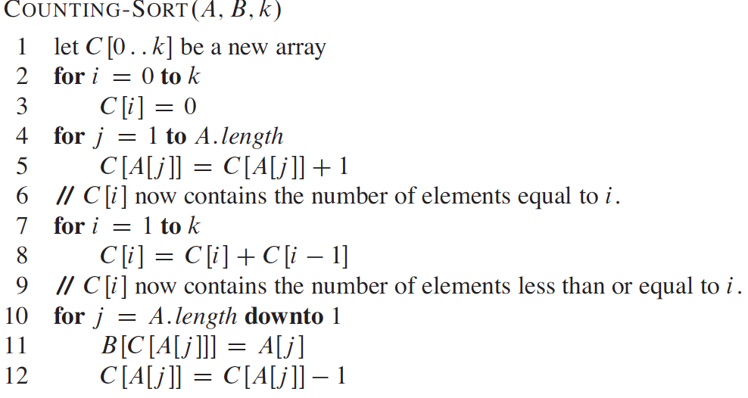

Consider the sequence A = {5; 5; 7; 6; 9; 8; 9; 6; 7; 8; 4; 2; 11}. (No need to justify results by tracing the algorithm). Justify only when explicitly asked you to.

1. (10 point) What should be k to efficiently and correctly execute Counting-Sort on Sequence A? **Why**?

The value k will be related to what the value of the highest element is. For our given sequence A = {5, 5, 7, 6, 9, 8, 9, 6, 7, 8, 4, 2, 11} the range will be [0..k] or [0..11]. So k = 11. This will be the foundation for the amount of iterations to fill in a completely sorted array. To start each of these values for A[j] up to k starting with 0, since this included as an integer number.

1. (10 points) Execute Counting-Sort on Sequence A. We are interested in the for loop Lines 4-5. Provide the array C right after the iteration j = 3 is executed.

Array C after the first 3 elements counted:

C[0, 0, 0, 0, 0, 2, 0, 1, 0, 0, 0, 0]

1. (10 points) Execute Counting-Sort on Sequence A. We are interested in the for loop Lines 4-5. Provide the array C right after the iteration j = 5 is executed.

Array C after the first 3 elements counted:

C[0, 0, 0, 0, 0, 2, 1, 1, 0, 1, 0, 0]

1. (10 points) Execute Counting-Sort on Sequence A. We are interested in the for loop Lines 4-5. Provide the array C right after the iteration j = A.length-1 is executed.

Array C after n elements counted:

C[0, 0, 1, 0, 1, 2, 2, 2, 2, 2, 0, 1]

1. (10 points) Execute Counting-Sort on Sequence A. We are interested in the for loop Lines 7-8. Provide the array C right after the iteration i = 5 is executed.

C[0, 0, 1, 1, 2, 4]

1. (10 points) Execute Counting-Sort on Sequence A. We are interested in the for loop Lines 7-8. Provide the array C right after the iteration i = 7 is executed.

C[0, 0, 1, 1, 2, 4, 6, 8]

1. (10 points) Execute Counting-Sort on Sequence A. We are interested in the for loop Lines 7-8. Provide the array C right after the iteration i = k-1 is executed.

C[0, 0, 1, 1, 2, 4, 6, 8, 10, 12, 12]

1. (10 points) Execute Counting-Sort on Sequence A. We are interested in the for loop Lines 10-12. Provide the array C right after the iteration j = 5 is executed.

C[0, 0, 0, 1, 1, 4, 5, 7, 8, 11, 12, 0]

1. (10 points) Execute Counting-Sort on Sequence A. We are interested in the for loop Lines 10-12. Provide the array C right after the iteration j = 5 is executed.

C[0, 0, 0, 1, 1, 4, 5, 7, 8, 11, 12, 0]

It seems like this was a duplicate question? :/

1. (10 points) Execute Counting-Sort on Sequence A. We are interested in the for loop Lines 10-12. Provide the array C right after the iteration j = 5 is executed.

C[0, 0, 0, 1, 1, 4, 5, 7, 8, 11, 12, 0]

It seems like this was another duplicate question? :/ :/

**Appendix**: Grading: What is an OBVIOUS and CLEAR LINK?

Here is an example to explain what an **obvious and clear link** is and how we grade your work.

Consider the following problem:

"(100 points) John travels from Auburn to Atlanta in his car at a speed of 60 mph. Leaving at 8am, at what time will John reach Atlanta".

Here are the answers of three students and their scores:

* **Student 1** answers: "9:48am". Student 1 will get 25 points.
* **Student 2**answers : "John will reach Atlanta at 9:48am". Student 2 will get 25+15 = 40 points
* **Student 3** answers: "The time t to travel a distance d at speed v is equal to d/v = d/60mph. The problem does not provide the distance d from Auburn to Atlanta. Based on GoogleMaps, the distance from Auburn to Atlanta is approximately 108 miles (**document is attached**).

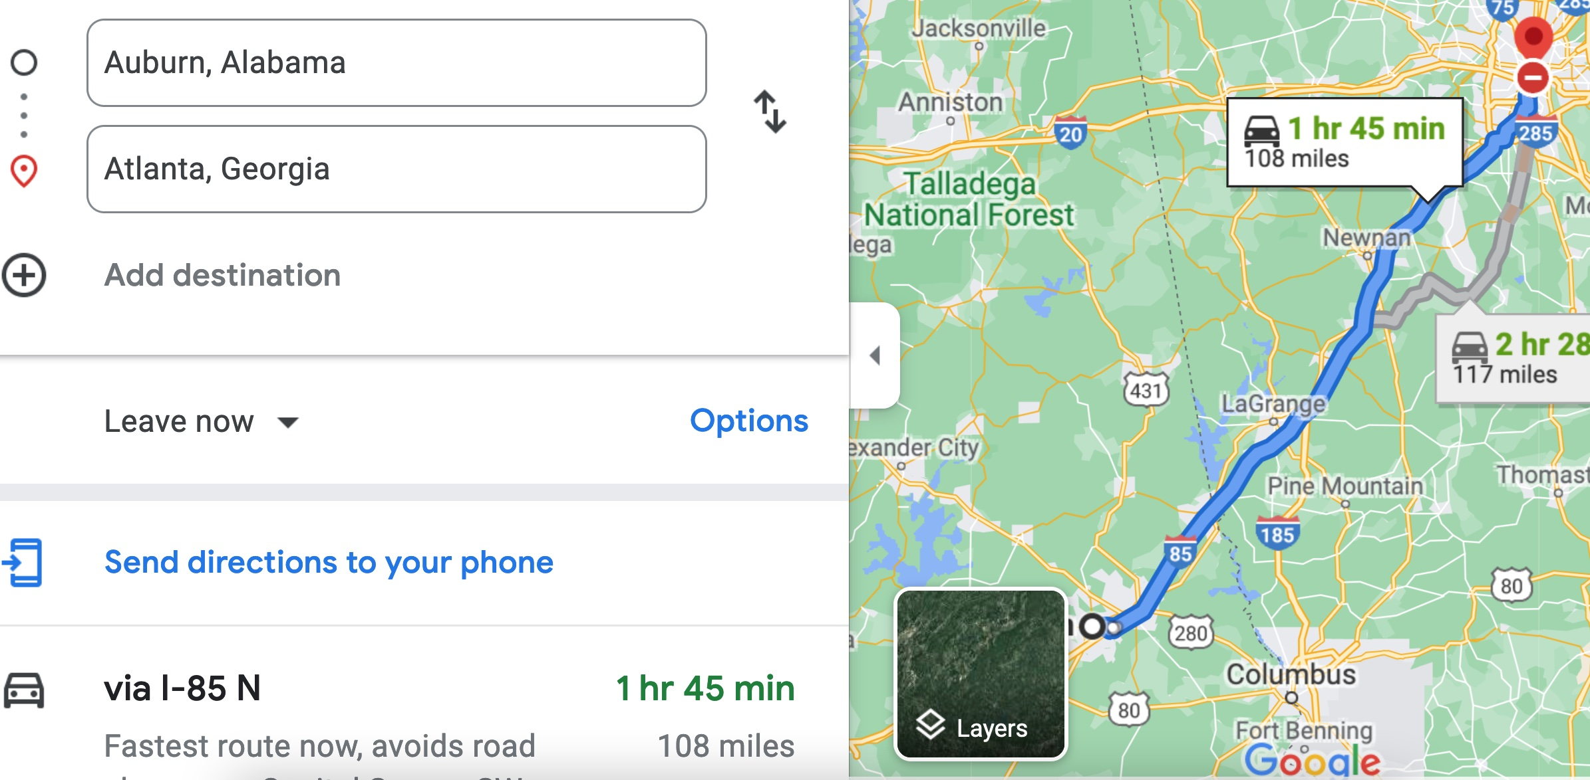

Therefore, the time t = 108 miles/60mph * 60 minutes/hour= 108 minutes. Since John left at 8am, he will then reach Atlanta at 8am + 108 minutes = 8 am + 60 minutes + 48 minutes = 9:48".

**Student 3** will get 25 + 15 + 60 = 100 points

Do you see the **direct** **link** going from the data provided in the question to the final answer, using general knowledge/formula and documents?.... Can you now solve the following problem and get 100 points?

"(100 points) Alice travels from Auburn to Atlanta in her car at a speed of 60 mph. Leaving at 8am, at what time will Alice reach Atlanta assuming that she had a flat tire that delayed her 30 minutes".